Faculty of Information Technology

University of Moratuwa

2022

**Project Proposal**

**Level 2**

**Procurement Workflow Information Management System**

The Architects

|  |  |
| --- | --- |
| Index Number | Name |
| **204067U** | **Gunawardana A.H.N.N.** |
| 204009V | Athukorala D.A.Y.S. |
| 204041K | Dilshan K.G.A.P. |
| 204065L | Gunathilaka M.D.K.L. |
| 204104H | Kularathna M.D.S.A. |

Supervisor

Dr. Premarathne S.C

(Department Of Information Technology)

Faculty of Information Technology

University of Moratuwa

2022

**Project Proposal**

**Level 2**

**Procurement Workflow Information Management System**

The Architects

**Contents**

1. Introduction 1

2. Background & Motivation 1

3. Problem in Brief 2

4. Aim & Objectives 2

5. Procurement Workflow Information Management System 3

6. Resource Requirements 7

7. References 7

Appendix - Plan of Action 8

**Figures**

Figure 1 - Process Flowchart 4

Figure 2 - Process Flowchart 5

Figure 3 - Process Flowchart 6

**Tables**

Table 1 - Action plan 8

Table 2 - Action Plan 8

1. Introduction

Companies face several issues on a daily basis due to not having a properly organized purchasing system. Some of these problems range from purchasing poor quality products and doing business without formal contracts to placing accidental orders. These issues are easily solved using a procurement management system.

2. Background & Motivation

A majority of large-scale companies worldwide have switched from manual systems to digitized procurement systems to overcome certain difficulties. Below is a brief explanation of what is expected from the system we are about to create.

There are several departments in a large-scale company. Each of these departments requires specific items to function for a certain period of time. The order for these items along with their budget and the evidence of authorization can be entered into the system. The evidence of authorization contains the reasons as to why these items are required by each department. These orders are collected and finalized in the purchasing department.

Afterwards, these orders are forwarded via the procurement system to the technical committee appointed by the finance division. Here the budgets and the reasoning behind these orders are checked thoroughly.

Next an approval has to be obtained from the procurement committee. A dedicated procurement system eases the duty of the procurement committee to send registration letters to existing and new vendors informing them that the bidding process for the required items is about to commence. The technical committee then uploads a report suggesting the vendors that best match our requirements.

Then the Finance division issues purchase orders to the vendors after obtaining the final approval from the Director General. These digitized approvals allow us to show exactly who is responsible for a certain order. If there was a problem in obtaining approvals, this could lead to accidental orders to which no one was accountable for. Therefore, we are motivated to give more attention to this.

Vendors will then issue a Letter of Acceptance and commence issuing goods after obtaining a Bank Guarantee or a Bond. After the goods have been received by the company, the Finance Division and the vendors have to submit Goods Received Notes and invoices respectively. These documents will have to be imputed into the system as evidence or future reference. It is only then the Finance division is free to release payments to the vendors.

3. Problem in Brief

Most purchasing systems used by companies have been identified to be outdated and obsolete. They suffer many difficulties due to the exploitation of system loopholes by vendors and irresponsible inside staff. Some of these difficulties are mentioned below

* Not managing a user-friendly interface. New users may struggle with complicated interfaces.
* Not having anyone accountable for accidental or unwanted purchases made.
* Manual systems take a lot of time to document the procurement proceedings.
* Manual processes may cost more money to manage.
* Not having proper evidence of transactions to refer to in future instances.
* Not following the proper steps and pre-conditions for procurement in the company.
* Not having all the relevant information about vendors and their products due to poor procurement methods. This may lead to bidding on a less appropriate seller.

4. Aim & Objectives

**Aim:**

The aim of this project is to develop a system to optimize the cost being invested by the organization via a process that involves sourcing, generating requests, placing the order, inspecting the supply received, sending invoices, and journaling the procurement process with the use of the Procurement workflow information management system.

**Objectives:**

* Study SQL, React, .net, and other technologies which are used for making the System
* Design activity diagram and SRC document and Database
* System should be able to grant access role base, and the system should maintain log file related to the user login/logout.
* Facilitate procurement officer to create master procurement plan by creating a new series
* HOD and End User able to create and manage procurement plan division-wise
* Ability to (The system) monitors activity deadlines and generate Alert/Emails to the relevant user(s) to initiate the procurement workflow activity
* Procurement Officer able to assign and manage TEC Committee and assign ‘Request to Initiate’ Document
* TEC Committee able to view, and manage approvals of assigned ‘RI’ Documents specifications,
* HOD, or End User able to Manage Pre-Bid Meeting, Bid Opening and Bid Closing
* Procurement Committee (Users) able to finalize the procurement based on the TEC Committees’ TEC report.
* Internal Auditor able to view and verify procurement committee-approved Bids
* DG (Director General/ Authorized Person) able to view Complete Approved
* Email notifications and a system alert will be generated whenever task is assigned to a user, and brief note about the task will be mentioned in the Email and Alert, when user access the procurement system alert window will display pending task that user should attend to
* The system able to log all interactions with the system.

5. Procurement Workflow Information Management System

It is required to implement a procurement workflow and therefore all staff, who are required to interact with the workflow (by providing necessary feedback), must be able to access the system (permission for both read and write, as necessary) in order to play their role (including recording their inputs in the system). Around 40 users would be required to be involved with the procurement process.

1. Main User Categories
2. Procurement Officer
3. Head of Department
4. Technical Committee
5. Procurement Committee
6. Director General
7. Internal Auditor
8. System Administrator

Figure 1 - Process Flowchart

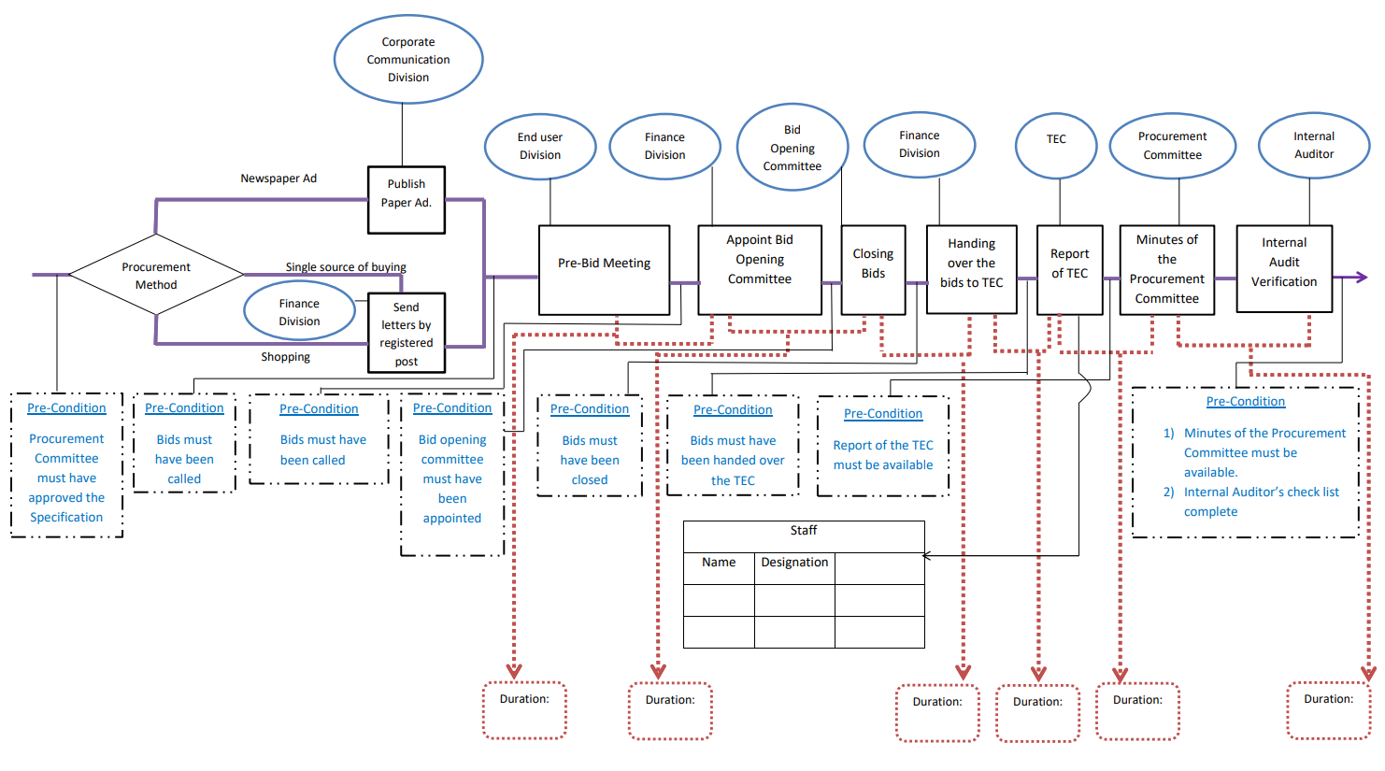

Figure 2 - Process Flowchart

Figure 3 - Process Flowchart

6. Resource Requirements

* Technical Resources
* Internet Connectivity
* Computer with 8GB RAM and 3.9GHz or more processing power
* React JS/Redux
* .net
* MySQL
* NodeJS
* Asp.net
* Bootstrap
* Hosting Services

# 7. References

|  |  |
| --- | --- |
| [1] | 11 best procurement software: Streamline purchasing in 2022, "Quandary Consulting Group," [Online]. Available: https://quandarycg.com/top-procurement-software-for-your-business/. |
| [2] | List of top procurement software 2022 , "TrustRadius," [Online]. Available: https://www.trustradius.com/procurement. |
| [3] | Oracle Cloud Platform Reviews & Ratings 2022 , "TrustRadius," [Online]. Available: https://www.trustradius.com/products/oracle-cloud-platform/reviews. |
| [4] | Pros and cons of SAP Ariba Procurement 2022 , "TrustRadius," [Online]. Available: https://www.trustradius.com/products/sap-ariba-procurement/reviews?qs=pros-and-cons. |
| [5] | Tipalti Reviews & Ratings 2022 , "TrustRadius," [Online]. Available: https://www.trustradius.com/products/tipalti/reviews. |
| [6] | What is procurement management?, "Oracle," [Online]. Available: https://www.oracle.com/erp/procurement/what-is-procurement. |

Appendix - Plan of Action



Table 1 - Action plan



Table 2 - Action Plan